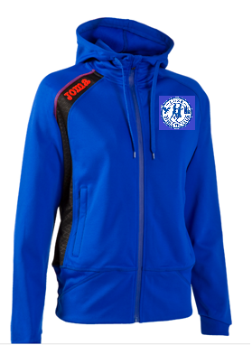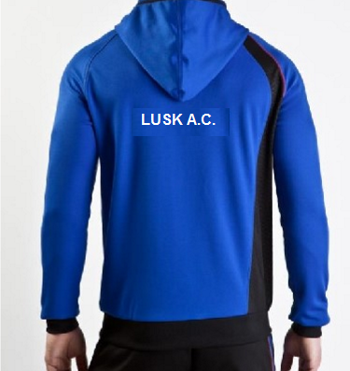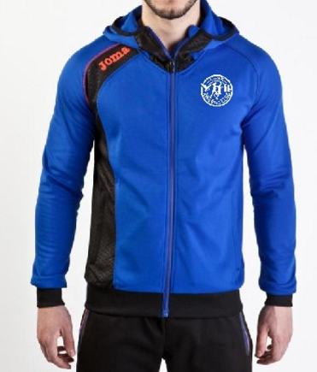
MENS – Black waistband arm cuff + trim around hood
LUSK A.C. Full Zip Hoody
** Special discounted rate for 10th May Only**
Sizing @ Shop Night:
Tuesday 10th May @ 6.45pm
or email Jacqui: clubgearluskathletics@outlook.com

LADIES – High waistband, fitted
TEXT ON REVERSE

€28 = Small / Medium / Large / XL / 2XL / 3XL
€23 = XS (age 14) / 2XS (age 12) / 3XS (age 10) / 4XS (age 8) / 5XS (age 6)
Design: Embroidered Lusk Logo on front. “Lusk A.C.” printed white on back. JOMA printed logo on right shoulder = salmon colour
Microfiber material – no shrinkage + no fading
Delivery 2 weeks from PO
**€10 deposit required to order**

